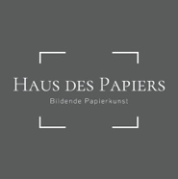

Press release
For immediate release
May 3rd 2023

As Never Before: Five winners announced in 2023 Paper Art Award

The evening of April 27th 2023 commemorates one of the most highly endowed awards ceremonies. The Paper Art Award at paper positions berlin nominates prizewinners at an international level within the world of contemporary paper art, awarding five winners for the first time this year.

The decision of the eight-member jury of experts for the Paper Art Award in Gold was clearly in favour of Ursula Sax, represented by Semjon Contemporary, whom the jury honoured for her artistic lifetime achievement. Annette Berr’s eulogy, Director of the Museum Haus des Papiers, paid tribute to Ursula Sax as a "grand dame of sculptural paper art", stating: "As a sculptor, she knows how to realise large, expressive, expansive forms in very individual works. She is a pioneer for women in the visual arts and the Paper Art Award jury is pleased to be able to purchase her paper art with the prize money for the collection of the Haus des Papiers in Berlin."

The Silver Award was split for the first time this year, between Gisoo Kim, represented by mianki Gallery, and Amparo Sard, represented by Anita Beckers Gallery. The Bronze Award was granted to Brian Dettmer, represented by Commeter Gallery, and Ken'ichiro Taniguchi, represented by Mikiko Sato Gallery.

According to the jury, the Paper Art Award’s Silver prize was split to "recognise the very different, and/or very independent artistic paths of the equally highly rated artists Gisoo Kim and Amparo Sard." The Bronze Award acknowledged two extraordinary approaches, aiming to encourage those of the winning artists.
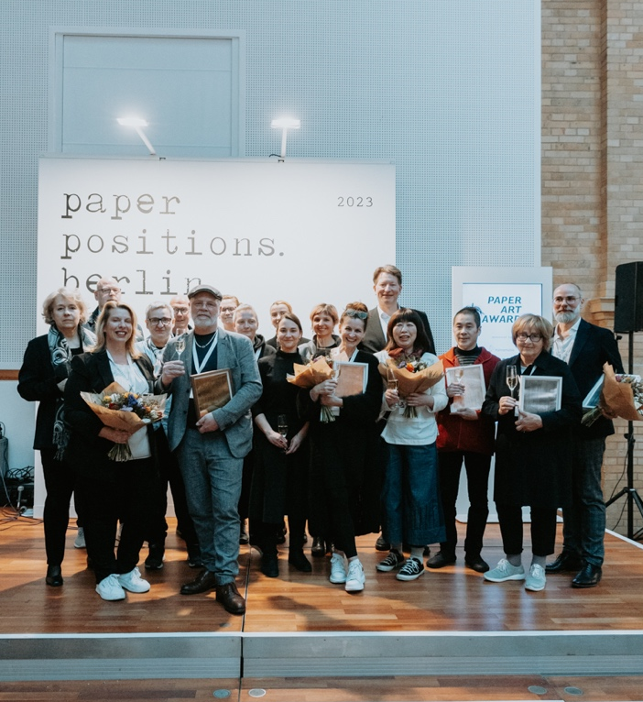
The Paper Art Award has been annually featured at the art fair paper positions berlin since 2021 and, with a total of € 36,000, is the most highly endowed art prize for sculptural paper art. It was initiated by the Fine Art-Print manufacturer d'mage, which has already been realising the paper residency in cooperation with Hahnemühle and Canon Germany since 2018. The three companies jointly sponsor the Paper Art Award with the aim of honouring first-class artistic positions that deal with the material paper in an outstanding, impulsive, and independent way.

The award-winning positions will be exhibited in the museum Haus des Papiers from June 8th 2023.
Paper Art Award 2023, Foto: Clara Wenzel-Theiler

